Ex. No: 6 — Use Sleuth Kit to Analyze Digital Evidence
Aim
To analyze a forensic disk image using The Sleuth Kit and examine the partition structure, file system, files, metadata, and recover a file from the digital evidence.
Tools Required
- The Sleuth Kit 4.14.0
- Windows Command Prompt
- Windows File Explorer
- Forensic Disk Image:
  - 4Dell Latitude CPI.E01
  - 4Dell Latitude CPI.E02
Evidence Used
The forensic image files were stored in:
D:\DF\
The evidence consisted of:
4Dell Latitude CPI.E01
4Dell Latitude CPI.E02
Procedure
Step 1: Identify Partition Structure
The mmls command was used to identify the partition structure of the forensic disk image.
Command:
mmls "D:\DF\4Dell Latitude CPI.E01"
The output identified an NTFS/exFAT partition beginning at sector 63. Therefore, an offset of 63 was used for subsequent file-system analysis.
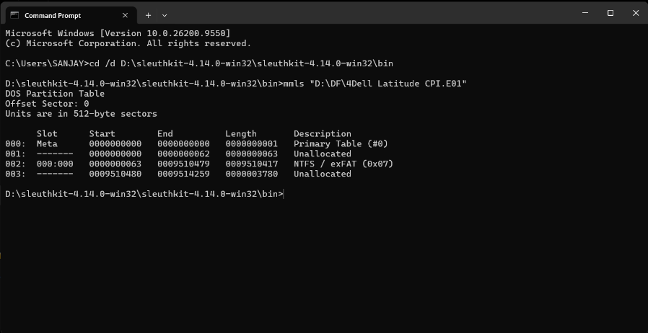
Fig. 1: Partition structure identified using mmls
Step 2: Analyze File System
The fsstat command was used to obtain information about the file system.
Command:
fsstat -o 63 "D:\DF\4Dell Latitude CPI.E01"
The output identified the file system as NTFS. The analysis also provided information about the MFT, sector size, cluster size, and root directory.
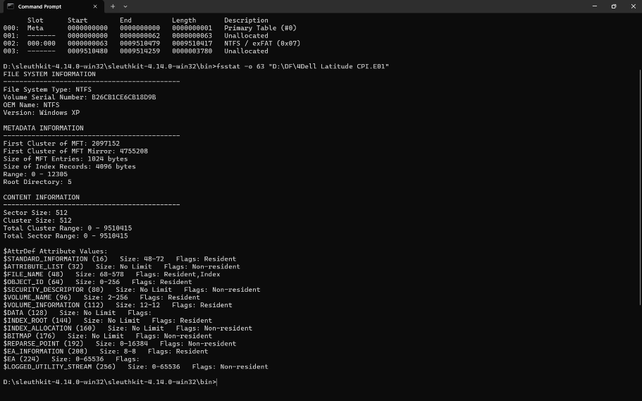
Fig. 2: NTFS file system information obtained using fsstat

Step 3: List Files and Directories
The fls command was used to recursively list files and directories in the forensic image.
Command:
fls -o 63 -r "D:\DF\4Dell Latitude CPI.E01"
The file Gone Fishing.bmp was identified in the output with MFT entry 5028.
r/r 5028-128-4: Gone Fishing.bmp
Fig. 3: Gone Fishing.bmp identified using fls

Step 4: Analyze File Metadata
The istat command was used to examine the metadata associated with Gone Fishing.bmp.
Command:
istat -o 63 "D:\DF\4Dell Latitude CPI.E01" 5028
The metadata showed:
- MFT Entry: 5028
- File Name: Gone Fishing.bmp
- Actual Size: 17,336 bytes
- Allocated Size: 17,408 bytes
- Parent MFT Entry: 458
- File System: NTFS
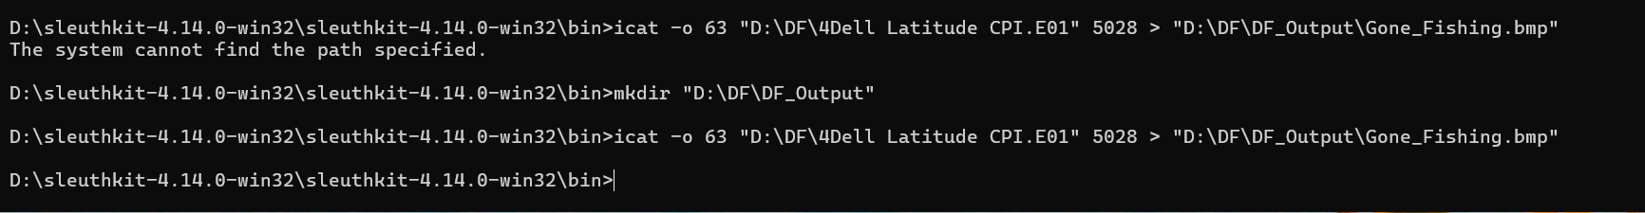
Fig. 4: Metadata of Gone Fishing.bmp obtained using istat

Step 5: Recover the File
The icat command was used to recover Gone Fishing.bmp from the forensic disk image.
The recovered file was saved in the DF_Output folder.
Command:
icat -o 63 "D:\DF\4Dell Latitude CPI.E01" 5028 > "D:\DF\DF_Output\Gone_Fishing.bmp"
The recovered file was stored as:
D:\DF\DF_Output\Gone_Fishing.bmp
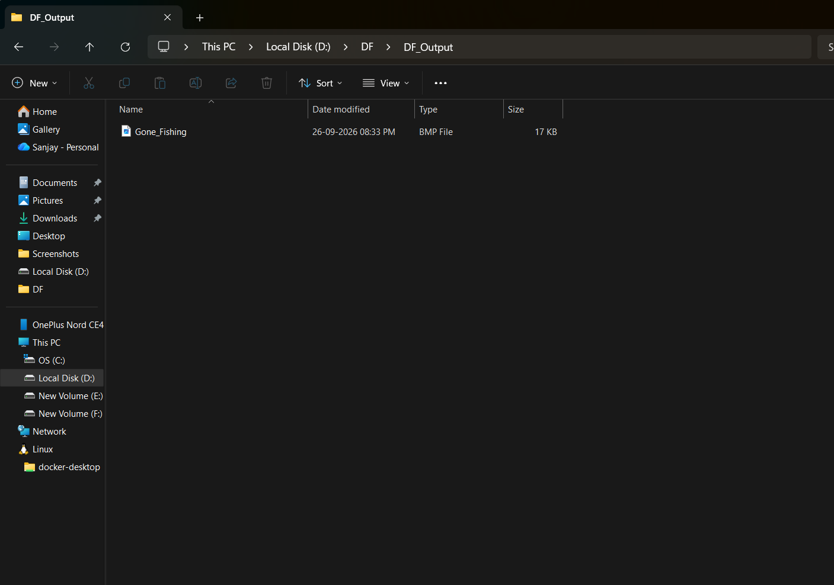
Fig. 5: Recovery of Gone Fishing.bmp using icat

Step 6: Verify the Recovered File
The recovered Gone_Fishing.bmp file was opened using Windows File Explorer. The image was displayed successfully, confirming that the file was recovered from the forensic disk image.
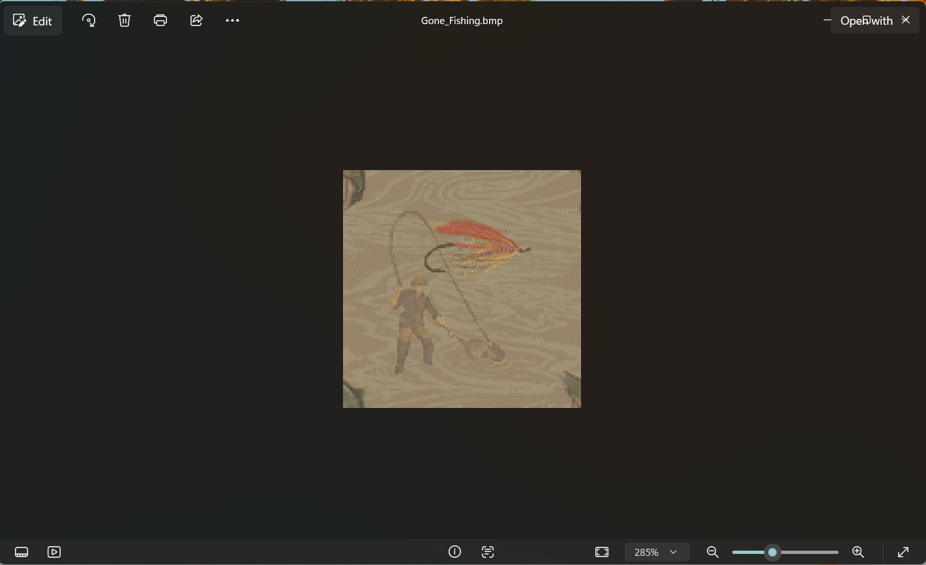
Fig. 6: Recovered Gone Fishing.bmp

Result
The forensic disk image was successfully analyzed using The Sleuth Kit 4.14.0. The partition structure and NTFS file system were identified, files and directories were listed, and Gone Fishing.bmp was identified with MFT entry 5028. Its metadata was analyzed using istat, and the file was successfully recovered using icat.

